**Edge Computing Laboratory**

**Lab Assignment 7**

**Name:** Gaurav Gadekar

**Class:** TY AIEC Batch C

**Enrollment No:** MITU23BTCSD120

**Roll No:** D2233120

**Title :** Study of Classification learning block using a NN Classifier on Edge Devices

**Objective:** Build a project to detect the keywords using built-in sensor on Nano BLE Sense / Mobile Phone **Tasks:**

* Generate the dataset for keyword
* Configure BLE Sense / Mobile for Edge Impulse
* Building and Training a Model

Study of **Confusion matrix**

**Introduction**

Edge Impulse is a development platform for machine learning on edge devices, targeted at developers who want to create intelligent device solutions. The "classification block" equivalent in Edge Impulse would typically involve creating a simple machine learning model that can run on an edge device, like classifying sensor data or recognizing a basic pattern.

**Materials Required**

• Nano BLE Sense Board

**Theory**

GPIO (General Purpose Input/Output) pins on the Raspberry Pi are used for interfacing with other electronic components. BCM numbering refers to the pin numbers in the Broadcom SOC channel, which is a more consistent way to refer to the GPIO pins across different versions the

Here’s a high-level overview of steps you'd follow to create a "Hello World" project on Edge Impulse:

**Steps to Configure the Edge Impulse:**

1. Create an Account and New Project:
   * Sign up for an Edge Impulse account.
   * Create a new project from the dashboard.
2. Connect a Device:
   * You can use a supported development board or your smartphone as a sensor device.
   * Follow the instructions to connect your device to your Edge Impulse project.
3. Collect Data:
   * Use the Edge Impulse mobile app or the Web interface to collect data from the onboard sensors.
   * For a "Hello World" project, you could collect accelerometer data, for instance.
4. Create an Impulse:
   * Go to the 'Create impulse' page.
   * Add a processing block (e.g., time-series data) and a learning block (e.g., classification).
   * Save the impulse, which defines the machine learning pipeline.
5. Design a Neural Network:
   * Navigate to the 'NN Classifier' under the 'Learning blocks'.
   * Design a simple neural network. Edge Impulse provides a default architecture that works well for most basic tasks.
6. Train the Model:

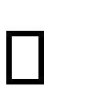 Click on the 'Start training' button to train your machine learning model with the collected data.

1. Test the Model:

 Once the model is trained, you can test its performance with new data in the 'Model Testing' tab.

1. Deploy the Model:
   * + Go to the 'Deployment' tab.
     + Select the deployment method that suits your edge device (e.g., Arduino library, WebAssembly, container, etc.).
     + Follow the instructions to deploy the model to your device.
2. Run Inference:

 With the model deployed, run inference on the edge device to see it classifying data in real-time.

1. Monitor:

You can monitor the performance of your device through the Edge Impulse studio.

**1 .DATASET-**



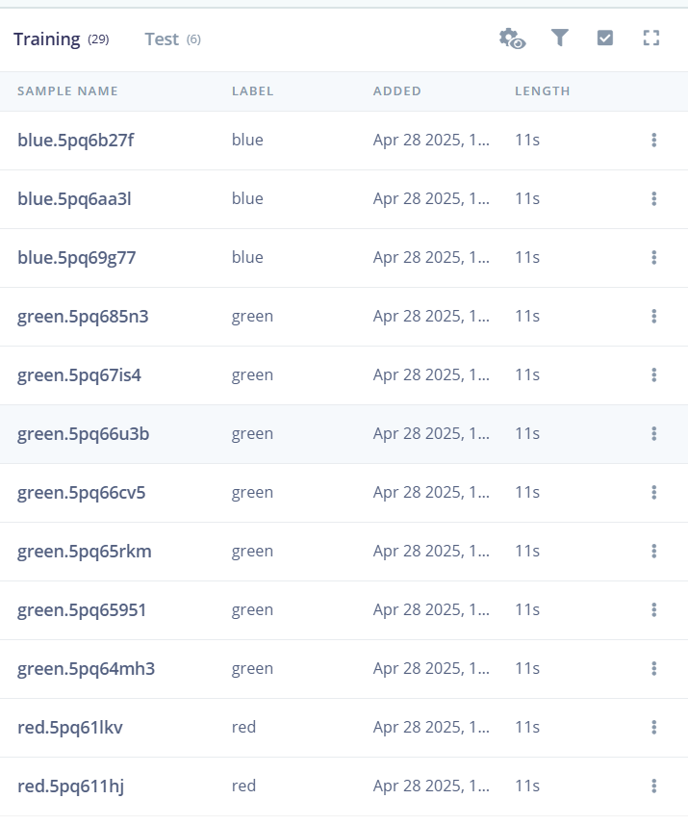

**2. Feature Extraction Image**

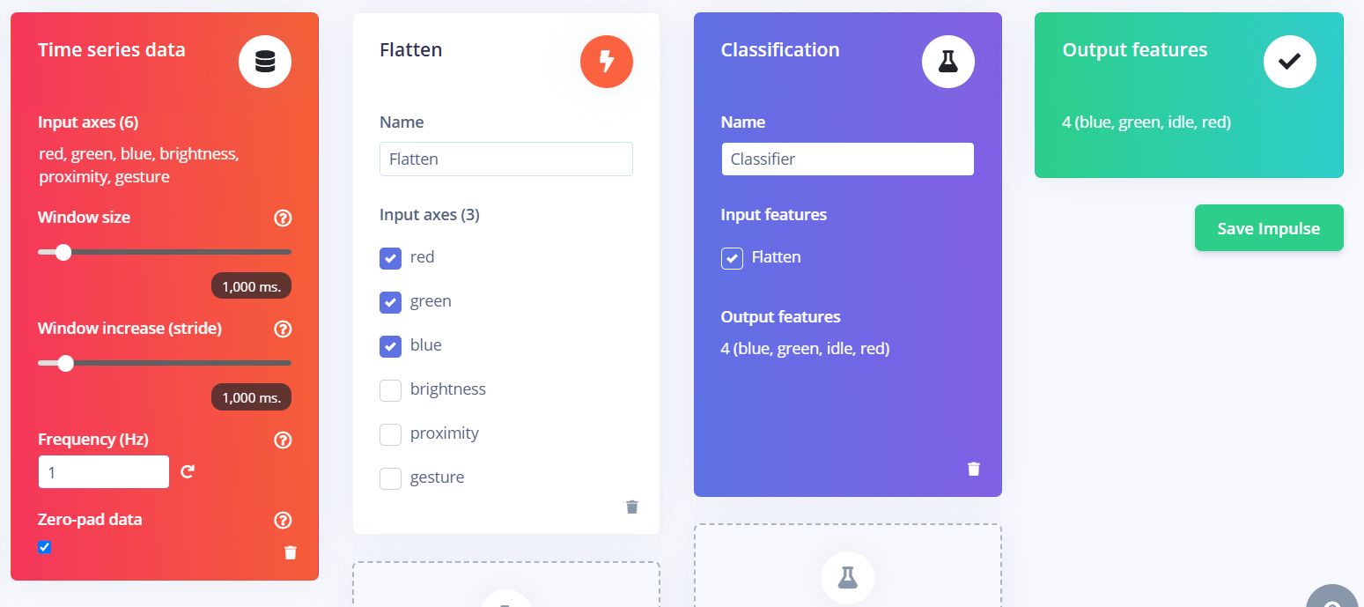

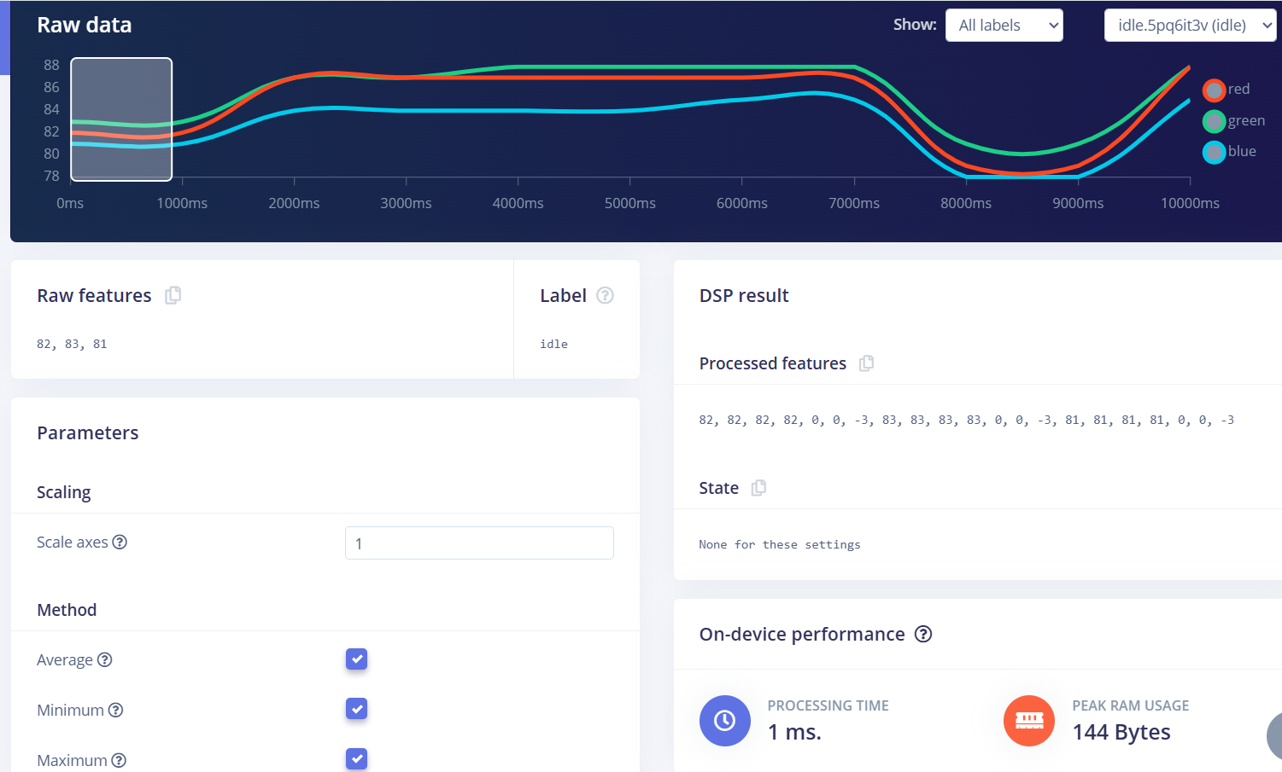

**3. Accuracy / Loss Confusion Matrix Image**

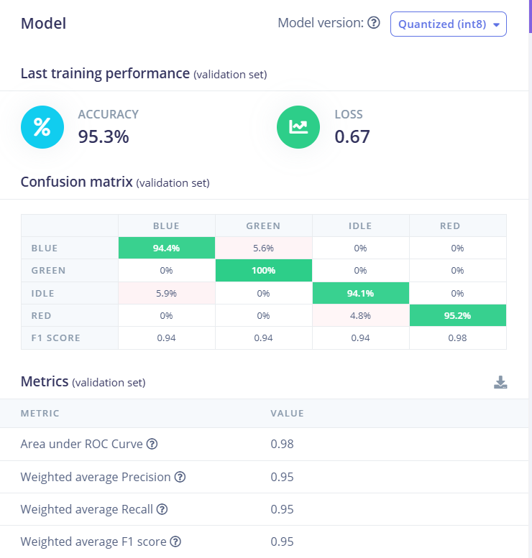

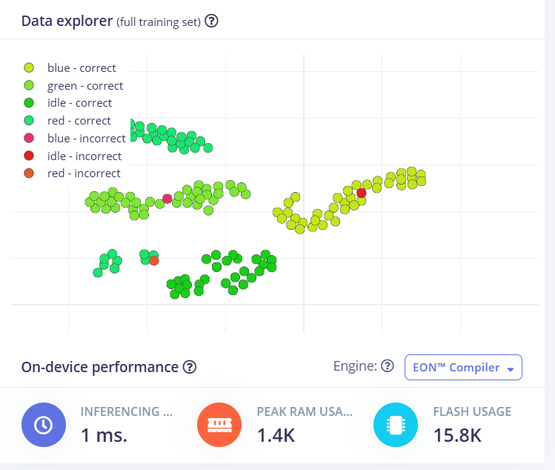

**4. Validation Result**

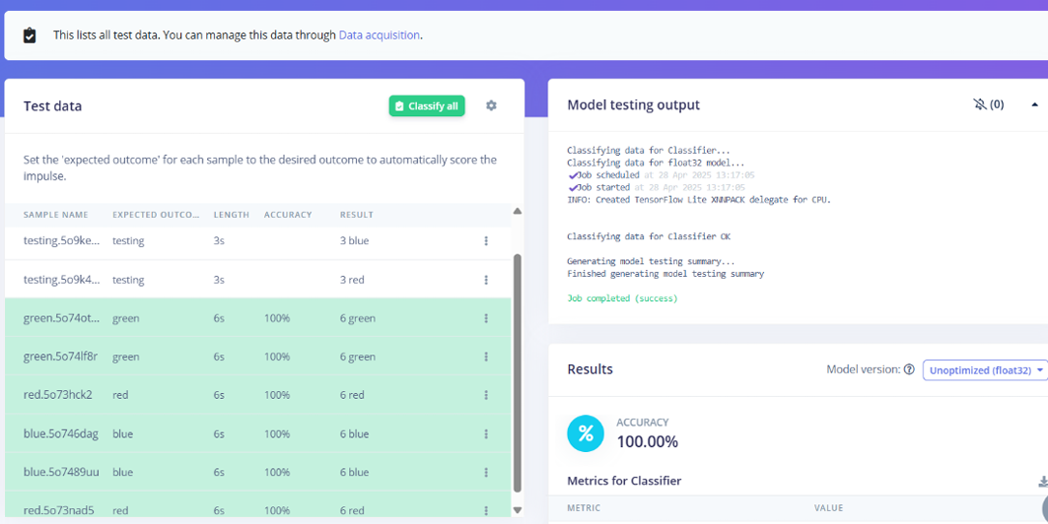

**5.CODE-**

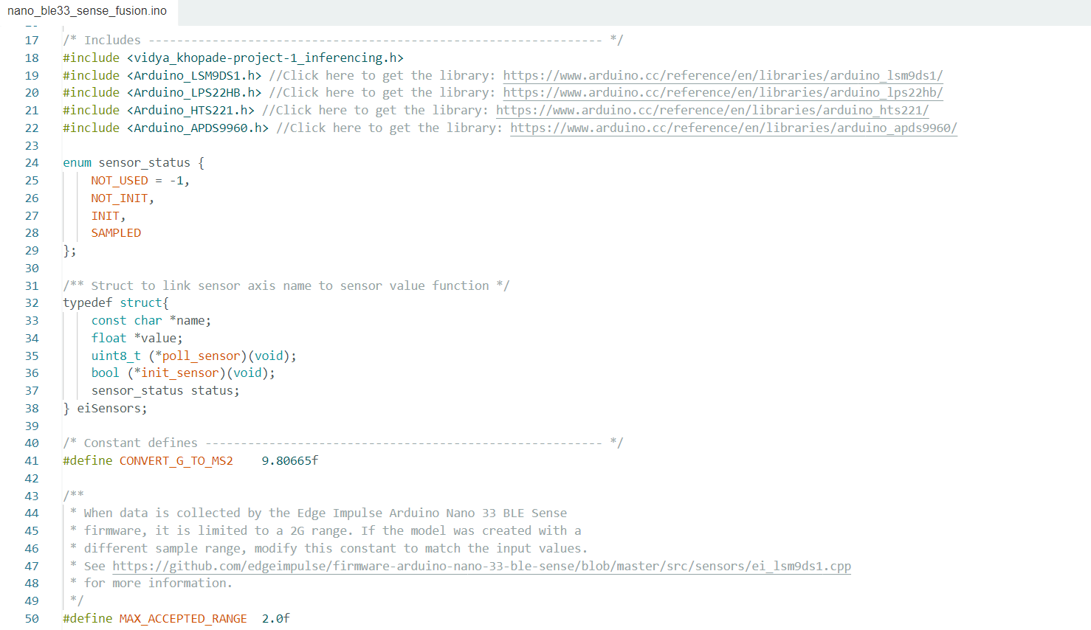

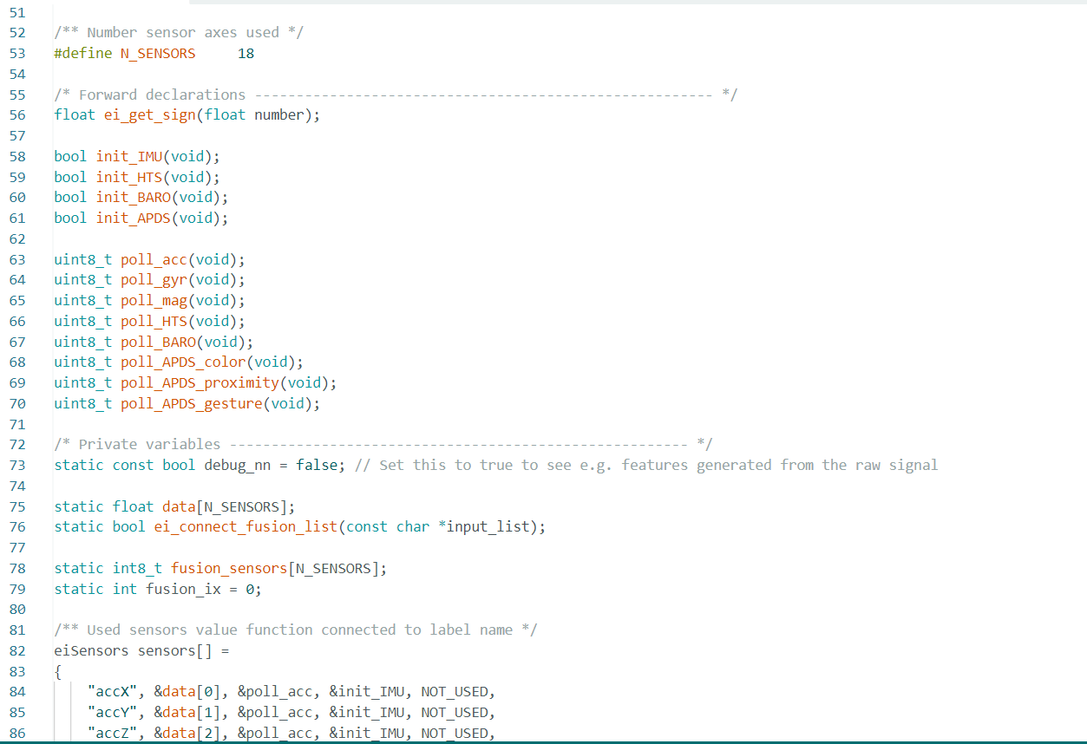

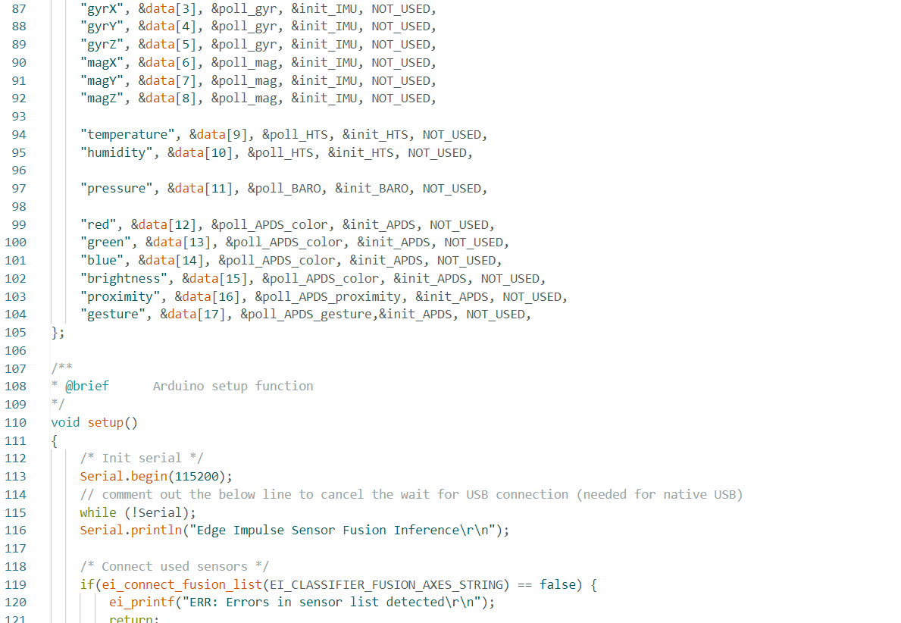

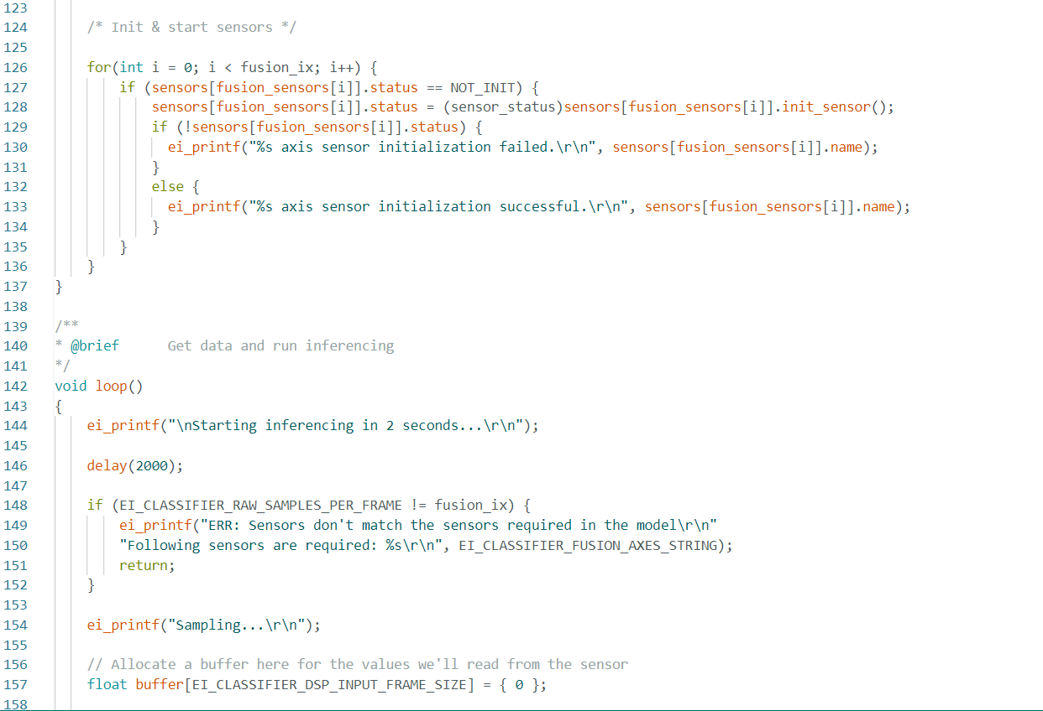

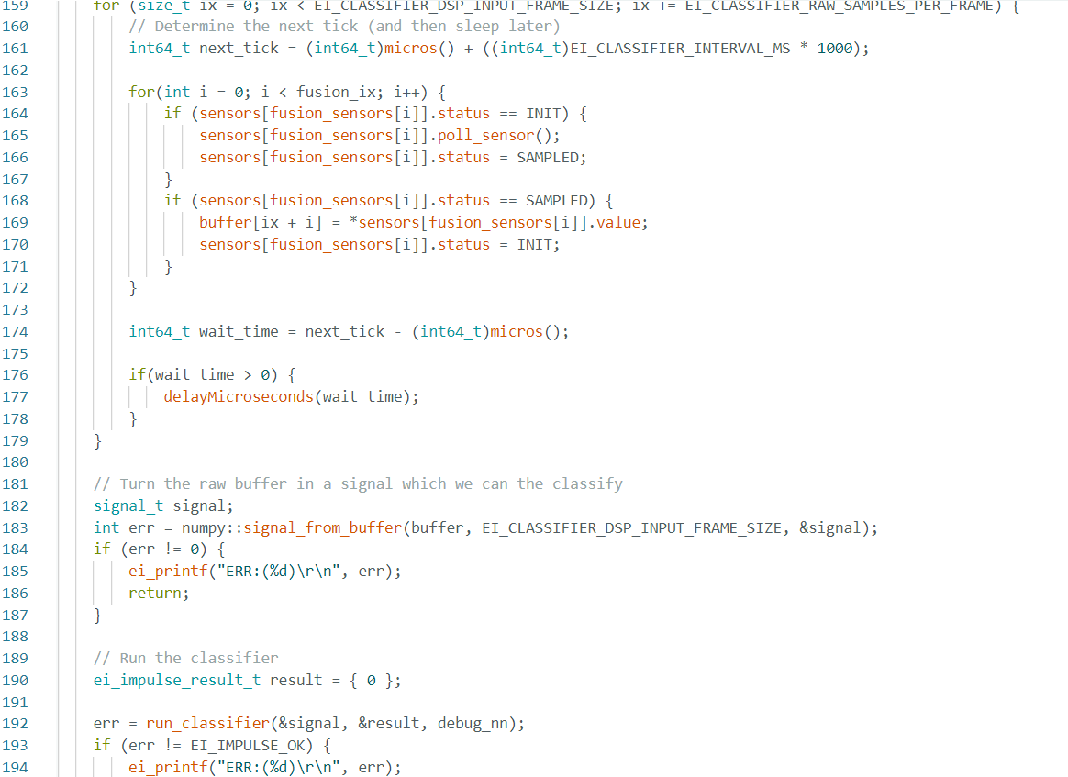

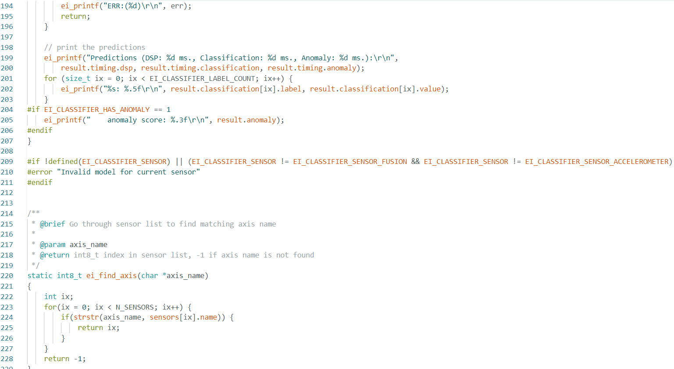

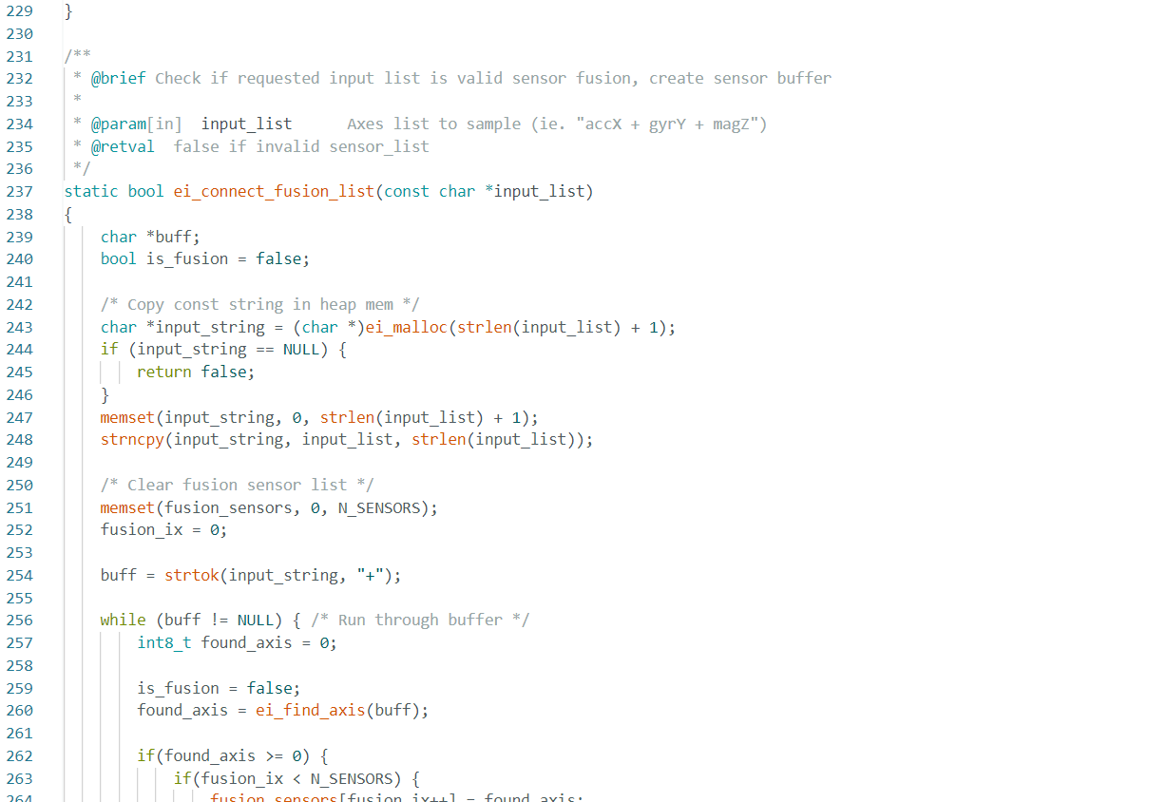

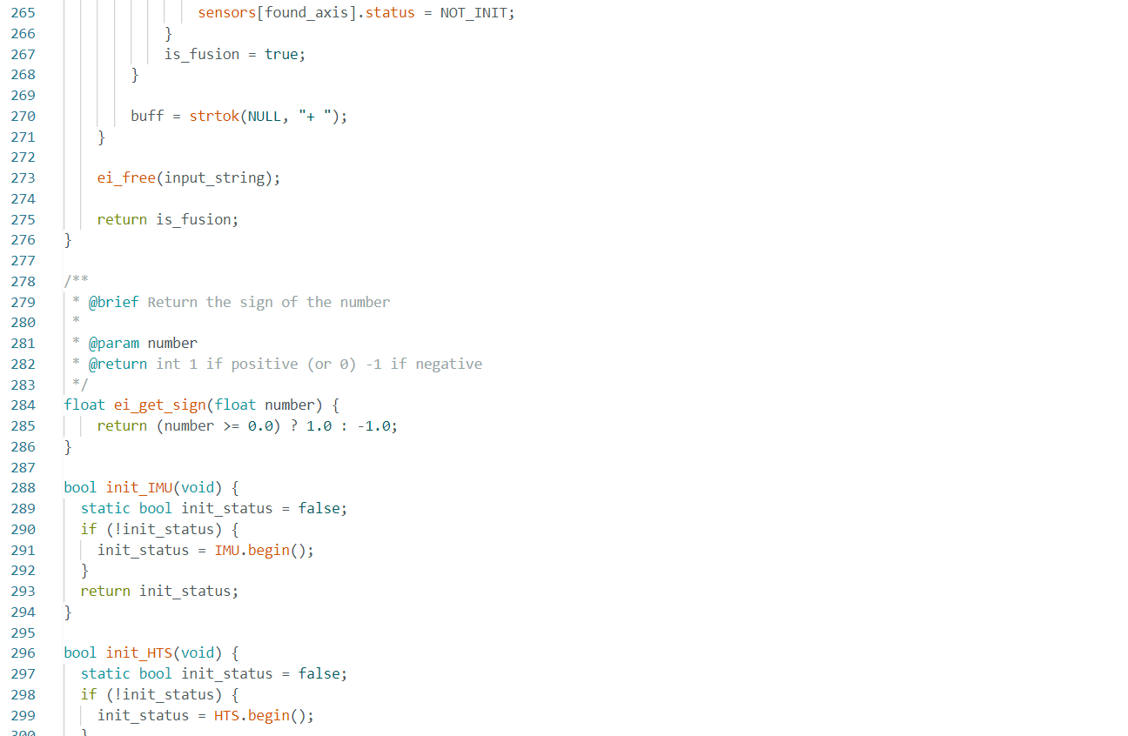

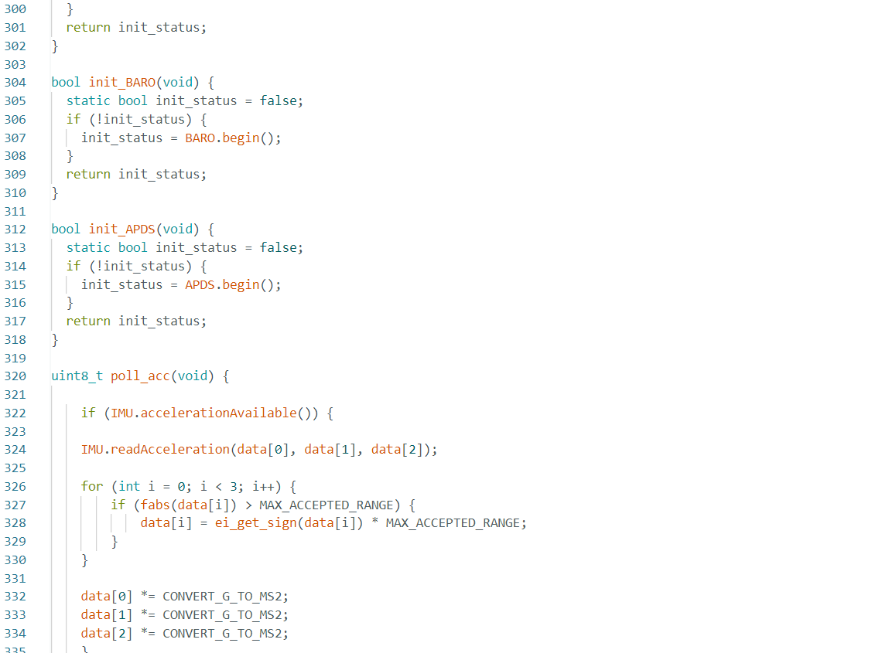

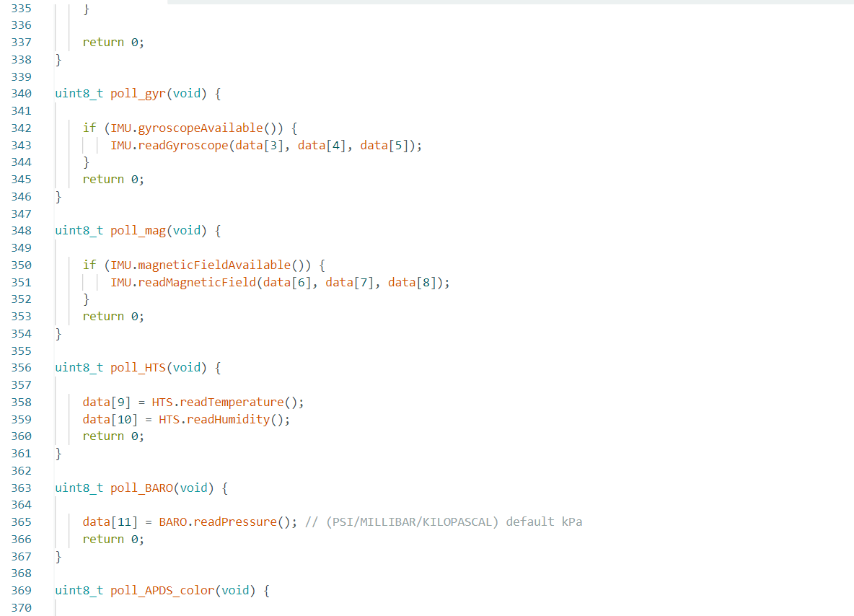

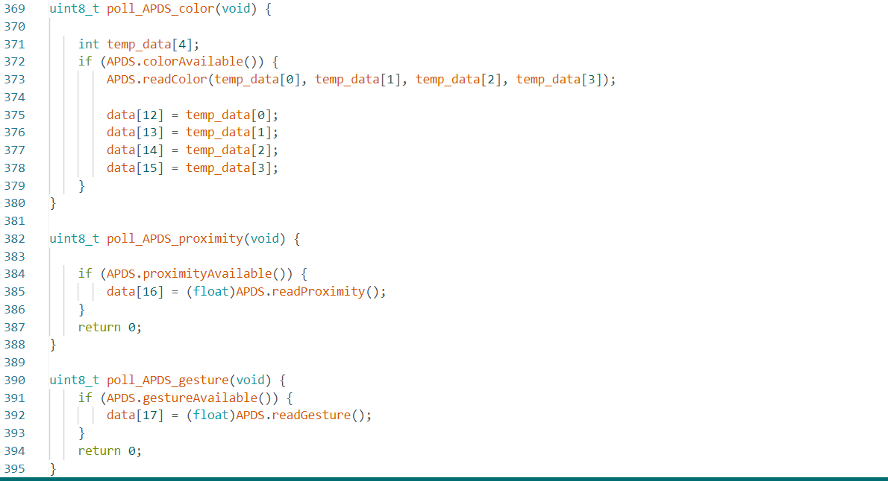

**6. Output**

